 **General Chemistry Lab I**

**Lab Component CHE101L**

**Guided Inquiry Experiments**

**Content: Lab 2**

**Chemistry Model Kit System: Chemical Bonding & Molecular Structures**

**Name ……………………………………………… Section ………….**

**Student ID……………………………………….**

**Date ………………………………… Time…………………….**

**Name of the instructor ……………………………………………………….**

**Signature & date ……………………………………………………….…**

**Report submission date (assigned by instructor) ……………………………**

|  |  |
| --- | --- |
| Title | Chemistry Model Kit System: Chemical Bonding & Molecular Structures (Molecule Shapes - Guided-Inquiry Activity) |
| Description | This Guided-Inquiry Activity includes the following earning goals. Students will be able to:  Determine electron geometry and molecule geometry for molecules using VSEPR theory.  Explain the role that nonbonding electron pairs play in determining molecule geometry.  Predict bond angles in covalent molecules as well as deviations from idealized bond angles. |
| Subject | General Chemistry Lab |
| Level | Undergrad - Intro |
| Type | Guided Activity |
| Duration | 180 minutes |
| Language | English |
| Keywords | [3D drawing](https://phet.colorado.edu/en/search?q=3D+drawing), [bonding](https://phet.colorado.edu/en/search?q=bonding), [geometry](https://phet.colorado.edu/en/search?q=geometry), [guided inquiry](https://phet.colorado.edu/en/search?q=guided+inquiry), [lone pairs](https://phet.colorado.edu/en/search?q=lone+pairs), [molecule](https://phet.colorado.edu/en/search?q=molecule), [shapes](https://phet.colorado.edu/en/search?q=shapes), VSEPR theory |
| Simulation(s) | [Molecule Shapes (HTML5)](https://phet.colorado.edu/en/simulations/molecule-shapes), [Molecule Shapes](https://phet.colorado.edu/en/simulations/molecule-shapes) |

**Lab 2_Session 1**

**Chemistry Model Kit System: Chemical Bonding and Molecular Structures**

**Introduction:**

Determination of Lewis Dot structures and visualization of the shapes of molecules using valence shell electron pair repulsion theory (VSEPR theory) is an example of an abstract concept that students often find difficult to learn. These topics are typically covered in the “Chemical Bonding” and “Molecular Geometry” chapters of all general chemistry textbooks. In this laboratory period, students will be asked to determine the Lewis Structures and the three-dimensional geometries of molecular species starting only with molecular formulas. Thus, there will be no wet lab work, per se. The lab time is to be used in helping students perfect their skills at deducing Lewis Structures and, most importantly, in helping students become acquainted with various molecular geometries. Model kits (in this case, a model of any atom from Styrofoam balls and toothpicks as connecting bonds) will be available so that the students can construct three-dimensional (3D) models of the molecules. Students will determine the shape of molecules and build a 3D model of those contained in an assigned list of candidate molecular species.

**Pre-Lab Assignment:**

Prior to the lab,students should/must study the sections of the textbook on chemical bonding, i.e., Lewis structures and molecular geometries (VSEPR, valence shell electron pair repulsion theory). Alternatively, or in addition, students can study the supplements to these experiments provided by the faculty as pre-lab reading.

**Pre-requisite Knowledge:**

1. Covalent bonding
2. Drawing valid Lewis structures for molecular compounds
3. Electrostatic repulsive forces
4. Valence shell electron pair repulsion theory (VSEPR)

**PhET simulation Activity Used:**

Molecular Shapes: <https://phet.colorado.edu/en/simulation/molecule-shapes>

**Techniques Used:**

Building models of molecules, making 3D drawings

**Concepts developed:**

Lewis Structures and geometries of VSEPR theory

**Special equipment and chemicals needed for the class:**

1. Styrofoam balls (Color Coded)
2. Toothpicks

**Procedure:**

For this lab, PhET interactive simulations (<https://phet.colorado.edu/en/simulation/molecule-shapes>) will be used to revisit Lewis Structures and VSEPR geometry understanding. This theory along with the simulations will help students to complete their worksheets containing molecular formulas for target molecules and ions. The VSEPR Summary Sheet (found below) will be given to the students only after they have completed the PhET simulation “Molecule Shapes Interactive Simulation”.1 After practicing with the models and other tools, students will work some of the examples for Lewis Structures without the use of model kits or simulation software so they can learn how to write them out by hand. **They will not have access to the PhET simulations during this practice.** The step-by-step procedure is as follows:

1. Distribute the worksheet to students to complete the valence electron count, Lewis structure, and formal charge columns.
2. Students work in groups to complete (with the help of Table 1) the columns for the next 5 examples given below. Those answers will be reviewed together.

**Tables:** Drawing Lewis structure and determining electron & Bonding domains

**Table 1:**

|  |  |  |  |  |  |
| --- | --- | --- | --- | --- | --- |
| **Number of Domains Around Central Atom** | **Electron Geometry (No lone pairs)** | **1 Lone Pair** | **2 Lone Pairs** | **3 Lone Pairs** | **4 Lone Pairs** |
| 2 Linear |  |  |  |  |  |
| 3 *Trigonal Planar* |  |  |  |  |  |
| 4 *Tetrahedral* |  |  |  |  |  |
| 5 *Trigonal Bipyramidal* |  |  |  |  |  |
| 6 *Octahedral* |  |  |  |  |  |

**Table 2:**

|  |  |  |  |  |  |
| --- | --- | --- | --- | --- | --- |
| **Formula of compound** | **Lewis Structure** | **Bond Angles** | **# Of bonding e- groups (central atom)** | **# Of non-bonding e- groups (central atom)** | **# Of total electron groups (central atom)** |
| CH4 |  |  |  |  |  |
| NH3 |  |  |  |  |  |
| H2O |  |  |  |  |  |
| BF3 |  |  |  |  |  |
| SO2 |  |  |  |  |  |

1. VSEPR Theory is introduced here using the PhET “Molecule Shapes Interactive Simulation”1 (<https://phet.colorado.edu/en/simulation/molecule-shapes>). Students should have devices with internet access (preferably through cell phones) for this is a guided activity that introduces students to valence shell electronic pair repulsion theory (VSEPR). It is a group/computer-based activity that takes a few minutes. Students will work in groups and complete the activity sheet.

**Table 3:** Drawing 3D Model with correct bond angles

|  |  |
| --- | --- |
| **Formula of the molecule** | **3D Model with correct bond angles** |
| CH4 |  |
| NH3 |  |
| H2O |  |
| BF3 |  |
| SO2 |  |

1. The worksheet completed by the students will be reviewed by the faculty with the help of PhET simulations software.

**Lab 2_Session 2**

**Chemistry Model Kit System: Chemical Bonding & Molecular Structure**

1. The model kits (in this case Styrofoam balls and toothpicks) will be distributed to the students to examine the different molecular geometries and compare to their drawings. Students will practice making models from the Lewis structures.
2. Students working in pairs are then asked to make the model for a set of specifically assigned molecules based on the electron pair and molecular geometry. After completing the ball-and-stick three-dimensional structure, students will take a snapshot of the molecule plus the details written on the accompanying identification paper, rename as their groups identification and save it for writing the report or directly submit to the Google classroom assigned folder.
3. After saving the image for their report or submitting the image of the molecules to the Google classroom, students will be given a list of compounds and post lab questions to complete at home and turn in to the Google classroom’s specified folder.
4. The student packets will be collected.

**Lab 2_Session 2 Worksheet**

|  |  |
| --- | --- |
| **Name & ID of the student:**   1. **Student 1:** | **Section: ………………………………………** |
| **Name and Formula of the molecule/species 1 given during lab:** | |
| **Lewis Structures:** | **# Molecular Geometry =** |
| 1. **Student 2:** 2. **Student 3:** | **# Valence electrons =** |

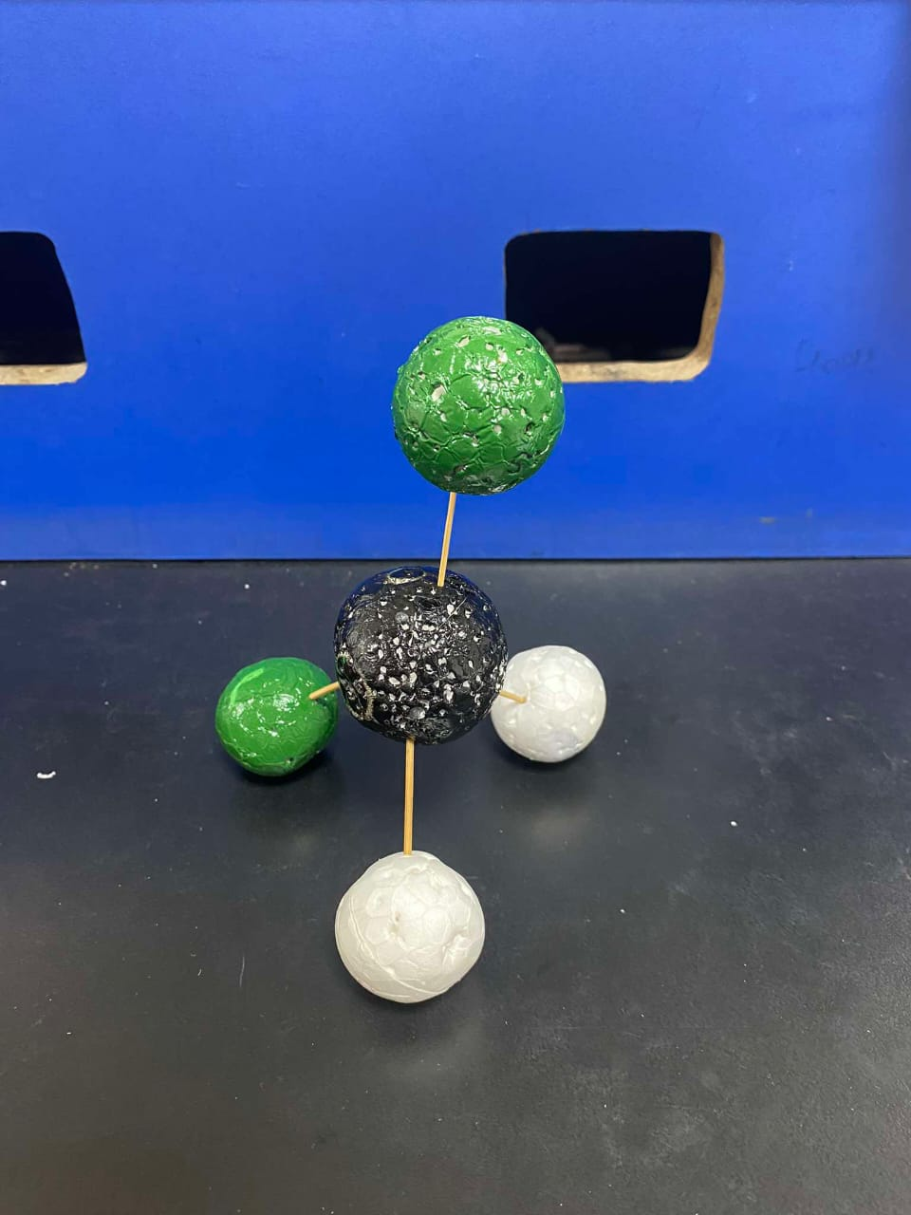

|  |  |
| --- | --- |
| **Name and Formula of the molecule/species 2 given during lab:** | |
| **Lewis Structures:** | **# Molecular Geometry =** |
|  | **# Valence electrons =** |

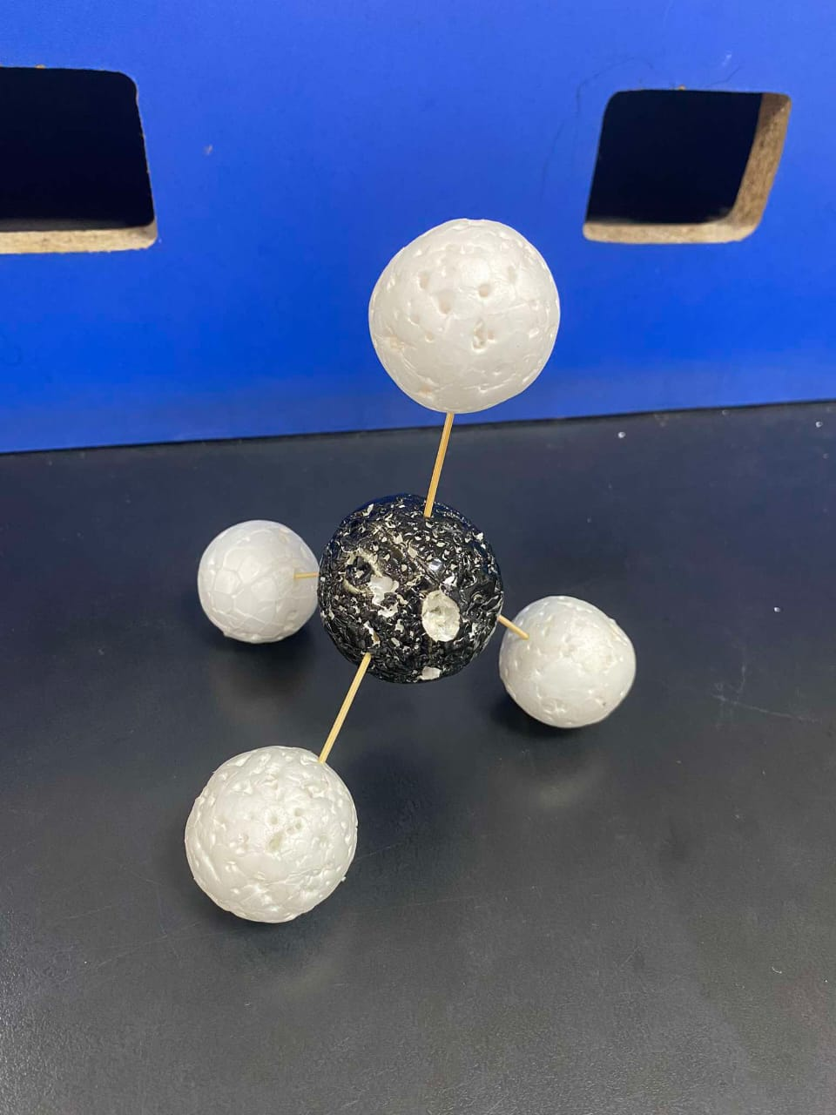

|  |  |
| --- | --- |
| **Name and Formula of the molecule/species 3 given during lab:** | |
| **Lewis Structures:** | **# Molecular Geometry =** |
|  | **# Valence electrons =** |

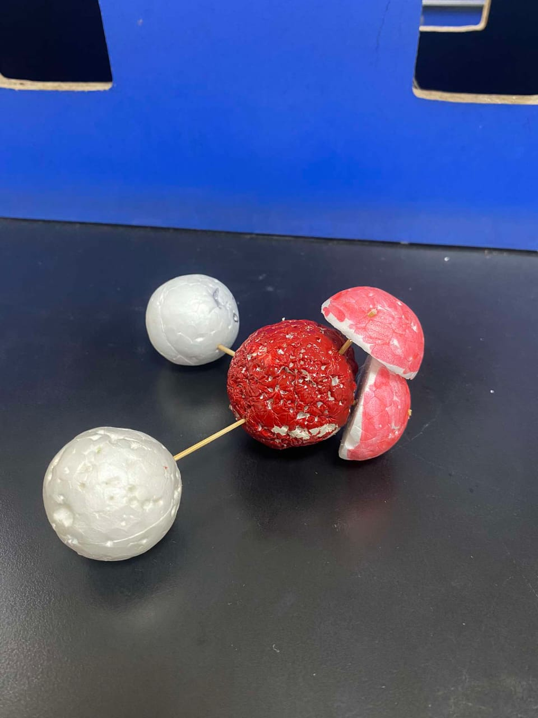

**References:**

1. Molecule Shapes Interactive Simulation: [http://phet.colorado.edu/en/simulation/molecule-shapes(link is external)](http://phet.colorado.edu/en/simulation/molecule-shapes) I use the Molecule Shapes - Guided-Inquiry Activity (by Timothy Herzog & Emily Moore) found under the Teacher’s menu on the main simulation page. [https://phet.colorado.edu/en/contributions/view/3947(link is external)](https://phet.colorado.edu/en/contributions/view/3947) (accessed 07/18/22)